Can You Win at Gambling? – Group 23

**Background and Motivation**

Motivation: As the Chinese New Year approaches, friends and family get together and spend quality time together. Along with Chinese new years comes the thing many people look forward to, Red Envelopes(紅包). With this money they received, some people may think of going to a casino. Of course no one wants to lose money when gambling so we want to find the best tactic so that you don't lose that much money. We wanted to know the largest amount we can earn in a few bets, then we can celebrate the new year with fatter wallets. ｡◕‿◕ ｡

Background: The near-miss effect is one of the main incentives for gambling, causing individuals to mistakenly believe that the result of losing money is bring them closer to winning rather than losing money. Over time, this seemingly similar outcome of winning money will fuel further misunderstandings that they do not often lose money, but is actually winning money, therefore increasing their motivation to continue gambling. We also wanted to explore this effect and see if it is true.

Problem Definition: Here we find the probability and expected value of the resultant amount of money you can end up with after 20 or 30 rounds of roulette respectively. In our project we chose to calculate and compare which tactic is the most optimal choice to win money from (or which you would lose the least from).

Game Description:

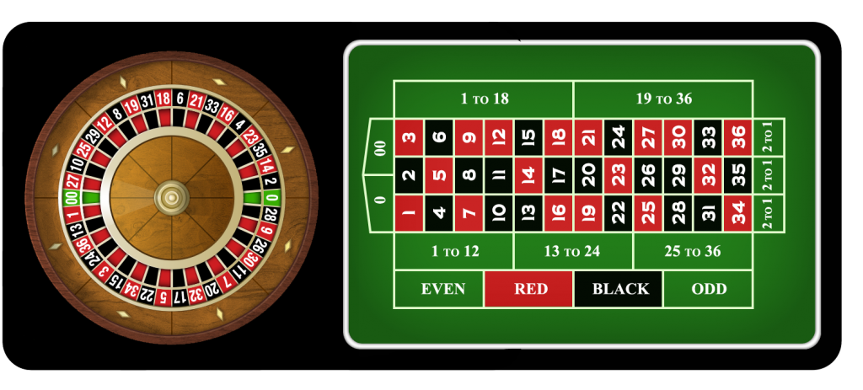

In the game Roulette, players may choose to place bets on either a single number, various groupings of numbers, the colors red or black, whether the number is odd or even, or if the numbers are high (19–36) or low (1–18).

To determine the winning number and color, a dealer spins a wheel in one direction, then spins a ball in the opposite direction around a tilted circular track running around the outer edge of the wheel. The ball eventually loses momentum, passes through an area of deflectors, and falls onto the wheel and into one of 38 (American style roulette) colored and numbered pockets on the wheel. The winnings are then paid to anyone who has placed a successful bet.

**Methodology**

We used the **Markov chain method** to calculate our problem. We assume that the probability of each round in a game do not affect each other and that we would stop once we reach our desired goal or when we have no more money left. We chose this method since every time we play 20 rounds the result wouldn't be the same, it would depend on which state we are at after each round according to a set probability.

We did this by organizing our transition matrix with the possibility of each state(the amount of money we have at the end of each round). As well as calculating the expected value of each tactic.

For every tactic, we start off with $10, we decide to play 20 rounds, for every round we bet $2. We decide to stop playing after 20 rounds or when we reach $0 where we cannot bid anymore or $20/$30.

**Data Collection and Analysis Result**

Data Collection:

|  |  |  |
| --- | --- | --- |
| Roulette Bet | Payout | Probability |
| Even/Odd | 1:1 | 18/38 |
| Red/Black | 1:1 | 18/38 |
| Low/High | 1:1 | 18/38 |
| Even&Red / Odd&Black | 1:1 | 8/38(win ½), 20/38(win 2/2) |
| Odd&Red / Even&Black | 1:1 | 10/38(win ½), 16/38(win 2/2) |
| Even/Odd & Low/High | 1:1 | 9/38, 18/38 |
| Red/Black & Low/High | 1:1 | 9/38, 18/38 |
| Column / Dozen | 1:2 | 12/38 |

⇑Probabilities of winning if you bet on these sections.

Model Formulation:

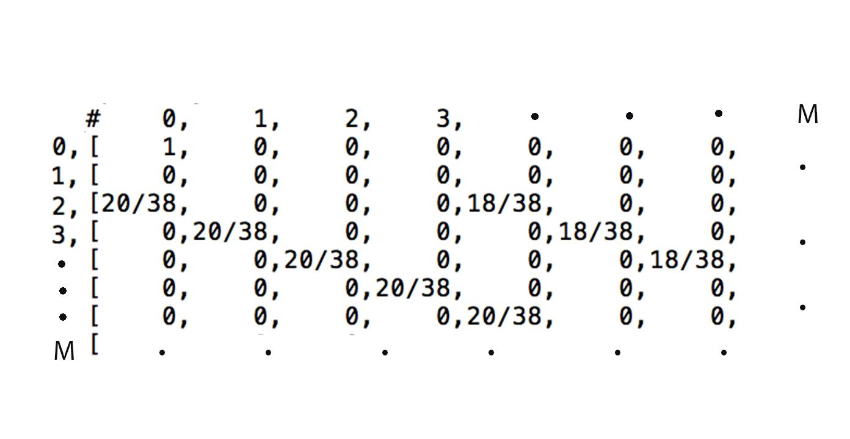

⇑An example of a transition matrix of the current amount of money the bidder has.

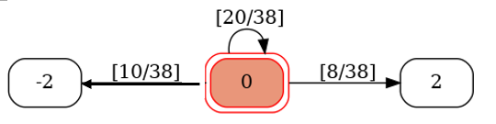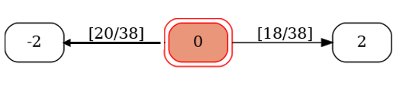

⇑An example of the single state flow diagram for one round.



⇑An example of the single state flow diagram for 20 rounds.

Analysis:

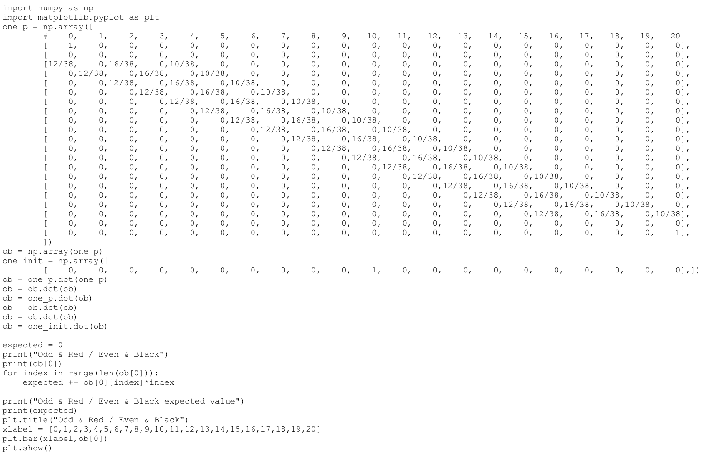

⇑Example of python code of how we calculated our results.

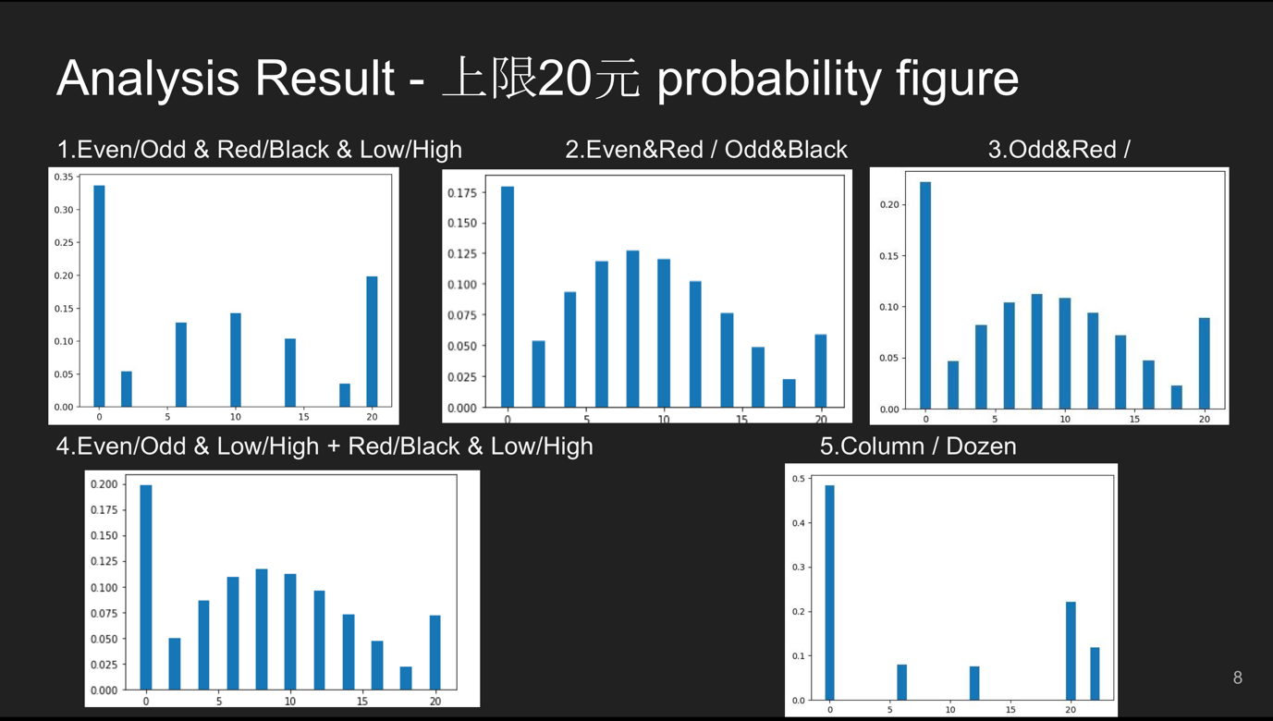

⇑The probability of each resulting state after 20 rounds or stopping once reaching $0 or $20.

Notice how the chances of winning all and losing all are much higher when bidding on a single section(1,5) and the chances of losing just a bit/ a safer way to bet is when you bet on two sections at once.(2,3,4).

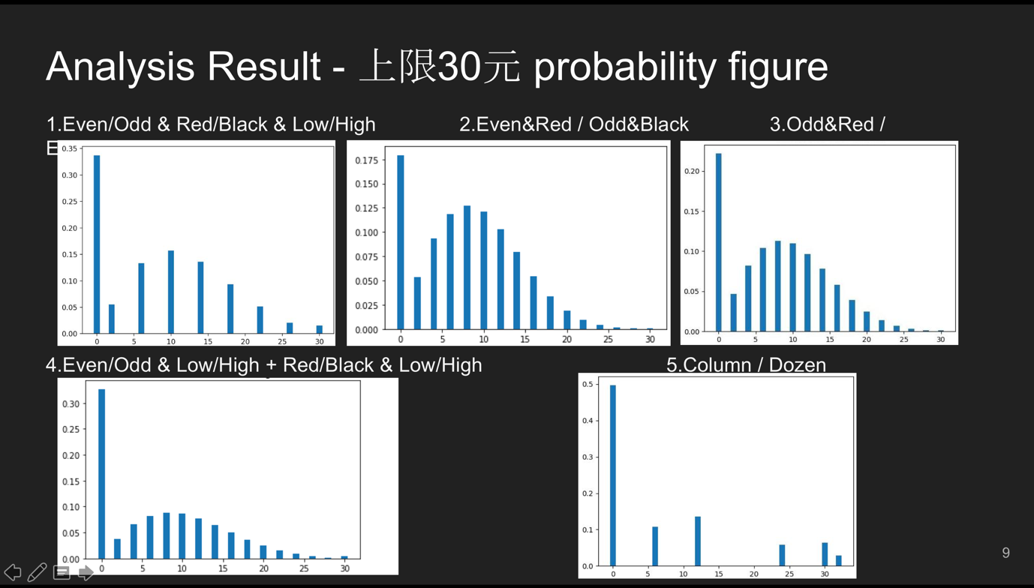

⇑The probability of each resulting state after 20 rounds or stopping once reaching $0 or $30.

These results are similar to that above, but it is much harder to win anything close to $30 in 20 rounds so you are more likely to lose money by continuing to try win money instead of stopping at $20 (above).

Both results still lean towards the left showing that majority of the time you’re still much more likely to lose money instead of winning.

|  |  |  |
| --- | --- | --- |
| Roulette Bet | Expected Value-上限20塊 | Expected Value-上限30塊 |
| Even/Odd  Red/Black  Low/High | 8.374713949056163 | 8.201945676458728 |
| Even&Red / Odd&Black | 8.043314862253071 | 8.006714767767914 |
| Odd&Red / Even&Black | 8.108338823285955 | 8.047390997183085 |
| Even/Odd & Low/High  Red/Black & Low/High | 7.90899672654373 | 7.018601283400339 |
| Column / Dozen | 8.79763243368719 | 8.464260496761755 |

⇑The expected values after 20 rounds ,stopping when state $0, $20 and $30 are reached.

Here we see that the even though we thought that bidding on two sections might be safer, the expected value shows that you are more likely to lose money using this method, its also proves the near miss effect we previously mentioned. Surprisingly the best bet option is to bet for the one with a lower probability of winning but a higher payout(column/dozen), however note that it is still based on luck, if you aren’t winning, it is better to play fewer rounds instead of trying again and falling into the near miss effect. (when you play with a lower limit eg $20 instead of $30)

**Conclusion**

1. Betting on only one type earned us a higher payout compared to betting on two types at the same time(a good example of the near miss effect).
2. Stopping once reaching $20 would be more beneficial. The more you play the more likely you are to end up losing more money than what you started with

In conclusion, the near miss effect is real and that you should not carry on betting thinking that you can win back what you lost and more, the more rounds you bet and gamble the higher your chance of accumulating loss and end up losing money.

Future research: we should not only stick to one tactic for all 20 rounds, we should adjust our tactic according to what state we are currently at.

**Best to just not gamble, Save your money instead and have a Happy New Year**  ｡◕‿◕｡